Here’s a summary of the main points from the transcript in 10 points or less:

1. **Commitment to the Project**: Leadership, including the speaker, emphasizes full commitment to the project, working alongside the team during evenings and weekends to prioritize its success.
2. **Top Priority and Resource Allocation**: The project is the highest priority for the division, and leadership will ensure the necessary resources are available to overcome any challenges.
3. **Learning Opportunity**: The project provides a valuable learning experience for everyone involved, allowing the team to develop expertise in essential processes that are core to the division’s operations.
4. **Integration Challenges**: The firm faces challenges with poorly integrated P&L processes across various functions such as books and records, balance sheet evaluation, backtesting, and regulatory reporting, particularly under Volcker.
5. **Inconsistencies in P&L Processes**: There are inconsistencies across the six or seven ways P&L is used in the firm, which creates difficulties in explaining these differences to regulators and management.
6. **Need for Reconciliation**: The team needs to implement a process to reconcile and explain differences in various P&L streams (e.g., clean P&L, books and records P&L), to achieve consistency.
7. **Immediate and Long-term Goals**: The team must both provide immediate explanations to regulators regarding current processes and work toward a long-term solution that ties daily P&L processes together more effectively.
8. **Pressure on Teams**: The project places significant demands on traders and middle office teams to execute daily reconciliation and long-term integration of P&L processes.
9. **Strategic Leadership and Support**: A leadership group, including key figures like Pekka and Angie, has been formed to drive the project, with plans to improve the P&L process and align it with risk management goals.
10. **Future Responsibility and Accountability**: The team is encouraged to take responsibility for improving the data and processes to ensure the successful implementation of long-term solutions, with ongoing updates and collaboration with regulators.

* Risk models generate sensitivities
* VaR models generate PnL distribution
* Trade activity generate PnL changes –from both New Trades and Trade Lifecyle events

**PnL Attribution** provides a critical product control function of decomposing and analyzing PnL and its variance in relation to “ Portfolio Risk, Portfolio trade events and VaR predicted PnL distribution

Attribution vs Explain. Flash vs Actual Vs Buy/hold PnL/ , Unexplained pnl

* Attribution vs Explain sometimes mean the same thing. Tough sometimes, **Explain is used to mean PnL due to market moves** while **Attribution is PnL due to everything else (Funding, new trades, ..)**
* Flash = FO view on predicted PNL. Usually calculated using T-1 sensitivities. May rely on unofficial closing market data and exclude other official PnL components ( CVA change, funding, transfer pricing)
* Actual PNL = is the official EOD PnL run and involves full revaluation of closing positions using closing market data and it includes all PnL components
* Flash PnL = when available at book/market close, offers an early warning indicator of where official Actual PnL is likely to be.

The benchmark for analyzing PNL attribution is Actual PnL

Buy %Hold PnL = subset of Actual PNL that includes components of PnL due to market movemetns , trade changes or lifecyles event affecting Start Of Day positions

* Risk-Based Explain is based on Taylor approximation

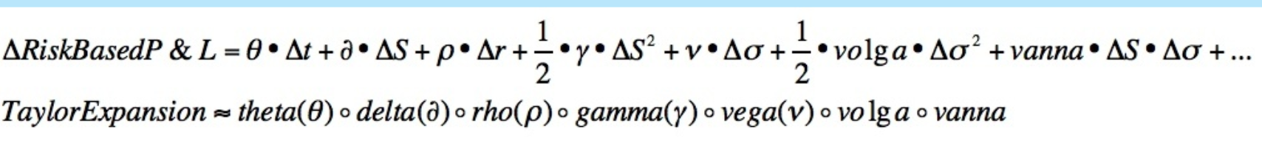

* **Full Revaluation involves a** repricing and has 2 flavor:
* Componet Side or Bump1-Reset1-Bump2-Reset2
  + Component slide may help identify PnL due to the change in a specific underlying (Credit spread curves) but will not distinguish between 1st order and 2nd order effects of that change ( Credit Spread delta vs Credit Spread Gamma)
  + Progressive Slide = Bump1 – Bump2- Bump3

**The position is revalued with each actual market data change applied sequentially, without reset. And PnL at each step due to all preceding changes attributed**

Because of the lack of reset between bumps: progressive slide will include in the incremental PnL captured at each dump/reprice, the cross effects between the current market change being applied and the previous market changes applied

That means: the incremental PnL attributed at each step will be sensitive to the order of which market data change are applied ….even though the end cumulative PnL is invariant.

**PLA and)the)Risk)Factor)Sensitivities hypothesis**

Risk production, which typically resides in the Market Risk function of the bank, includes, the generation of risk factor sensitivities for the bank’s trading positions. Market data for risk factors of a position is bumped in isolation and the position re-valued with the change in value reflecting the position’s sensitivity to the risk factor.

Change in value of a position in product A is materially determined by changes to variables b, c, d and parameters e, f and that change is quantified by the sensitivities obtained

To ensure that comparisons between Risk (including VAR and CVA), PLA and P&L at any of these summary levels are of apples to apples9 , it is important that the models, market, reference and static data inputs used in calculations and in aggregation are consistent.

**CVA reflects the difference between the default-risk free valuation of a portfolio; and the valuation that takes into account the counterparty’s default risk. Debt Value Adjustment (DVA) is the counterpoint that takes into account the impact of the bank’s own probability of default. I.e. Default Risky Valuation = Default Risk-Free Valuation – (CVA – DVA)**

**UnExplained PnL :**

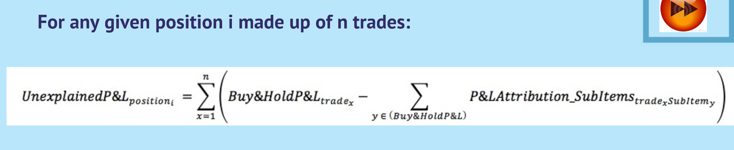

This assumes that all n trades are risk homogenous and that their PmL attribution is calculated using the same PnL Attribure methodology and valuation is done with consistent models and market data.

When aggregating UnExplained PnL across positions that are either or not risk or methodology homogenous, sum of Absolute is appropriate

